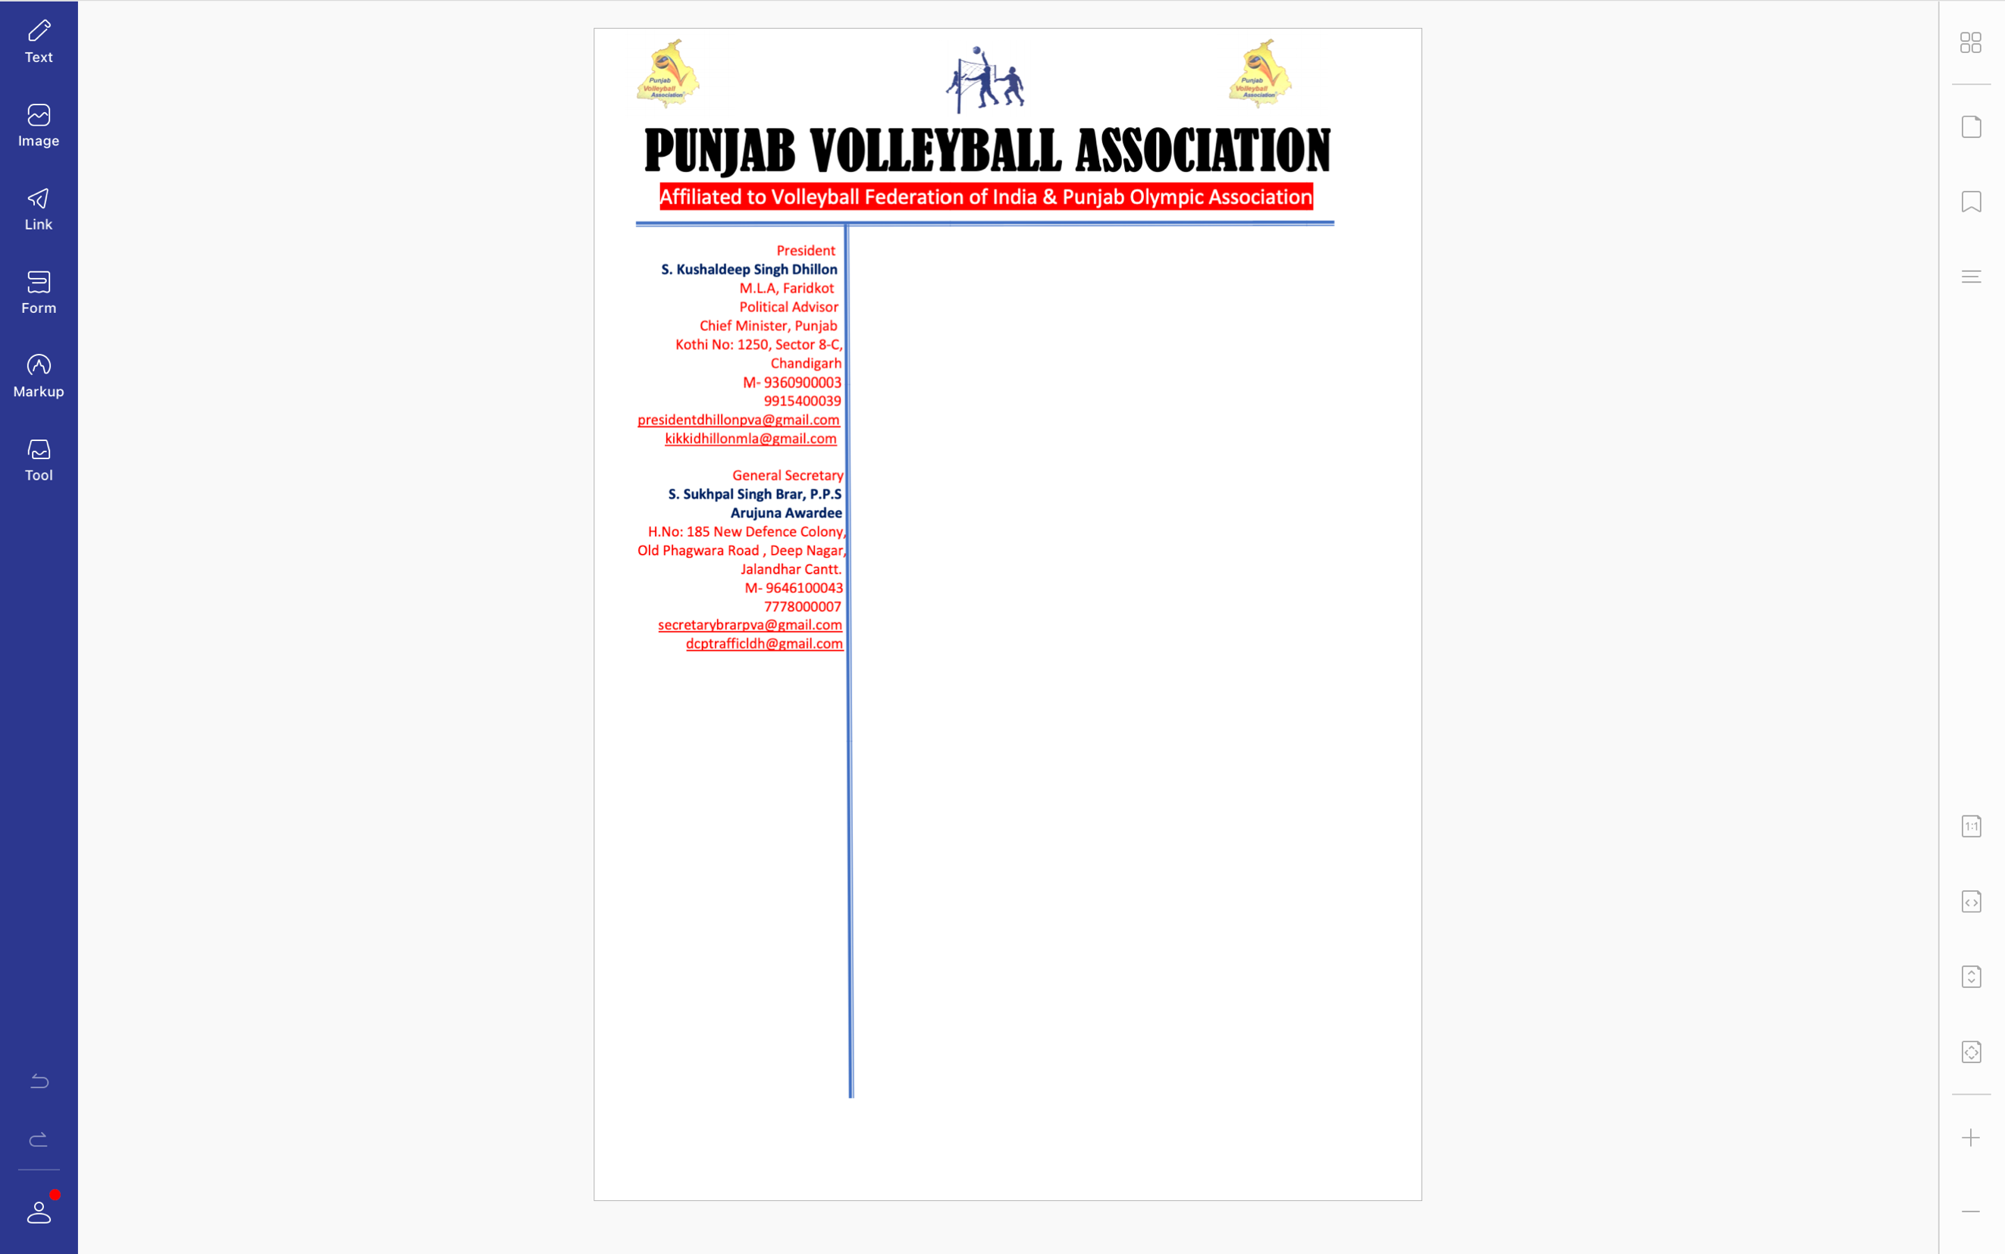



**Ref. PVA/BRAR/2022/Spl.-(1)/0222** Dated: 02-08-2022

To,

President

Punjab Olympic Association

Sub: Submission of annual fee

Sir,

With reference to the above mentioned subject I would like you to inform that the annual fee of INR 10,000/- (Rupees then thousand only) had already been paid vide draft number 251625 of Punjab and Sindh bank, branch Govt. Barjindra college, Faridkot dated 01-08-2022. The copy of the said draft is also attached along with this letter for your worthy consideration. Kindly do the needful

Regards,

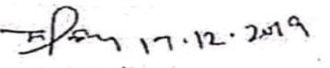

S. Sukhpal Singh Brar, Arjuna Awardee

General Secretary

Punjab Volleyball Association

